**The exec Function**

**LAB # 04**



**Fall 2023**

**CSE-302L Systems Programming Lab**

Submitted by: **Ali Asghar**

Registration No.: **21PWCSE2059**

Class Section: **C**

“On my honor, as student of University of Engineering and Technology, I have neither given nor received unauthorized assistance on this academic work.”

Submitted to:

**Engr. Abdullah Hamid**

Date:

**1st February 2024**

**Department of Computer Systems Engineering**

**University of Engineering and Technology, Peshawar**

**Task 1:**

Write a program that takes N UNIX commands as arguments, creates N child processes, each of them implementing their respective commands. Parent process shall wait for all the child processes and receive and print the exit status of the child processes.

**Code:**

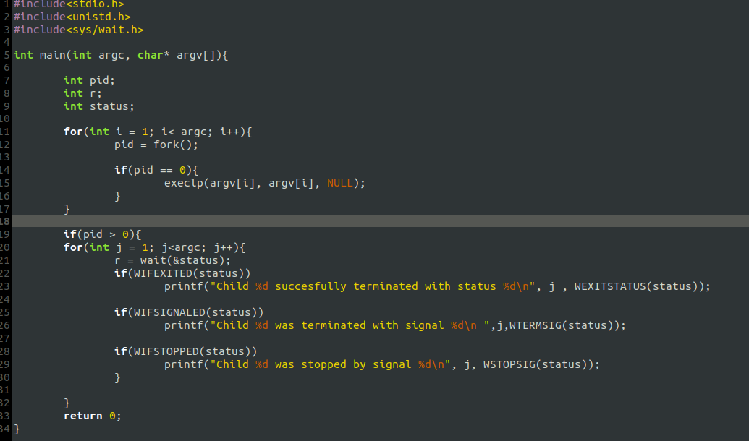

**Output:**

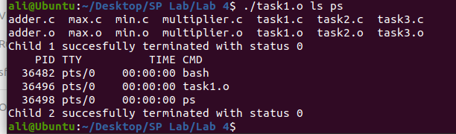

**Task 2:**

a. Write a program that takes integers as arguments and adds them.

b. Write a program that takes integers as arguments and multiplies them.

c. Write a program that takes integers as arguments & adds & multiplies them using the above two programs.

**Code:**

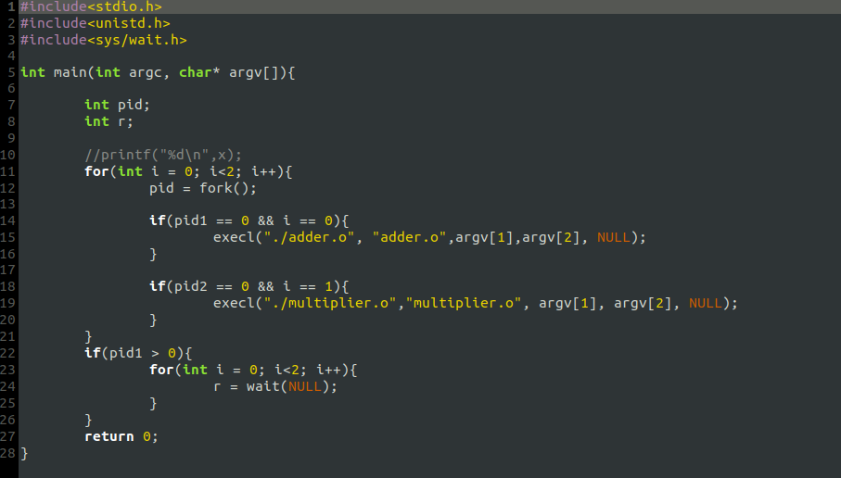

Task2.c

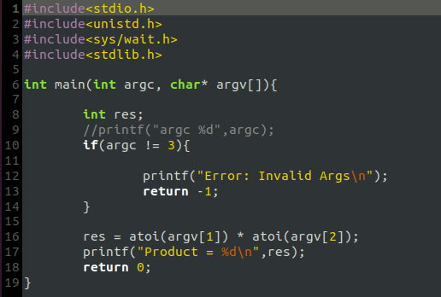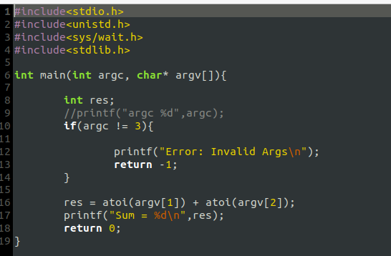

multiplier.c

adder.c

**Output:**

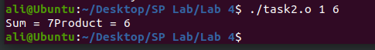

**Task 3:**

Write a program **“minmax.c”** that takes an array as command line arguments. Program executes **min.c** and **max.c** programs in its two child processes. One child process calculates and returns the min value and other calculates and returns the max value in the array. The program **“minmax.c”** shall receive the values returned by the child processes and display these values.

**Code:**

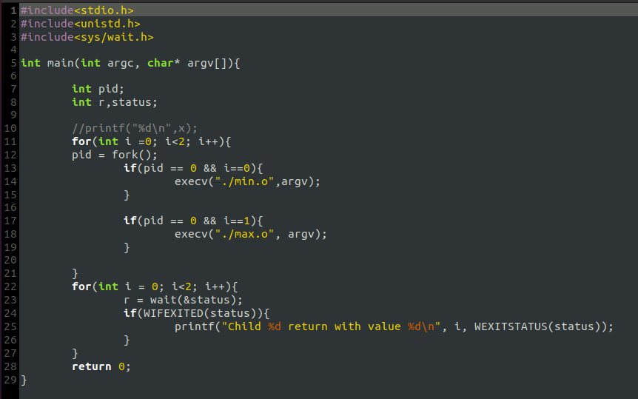

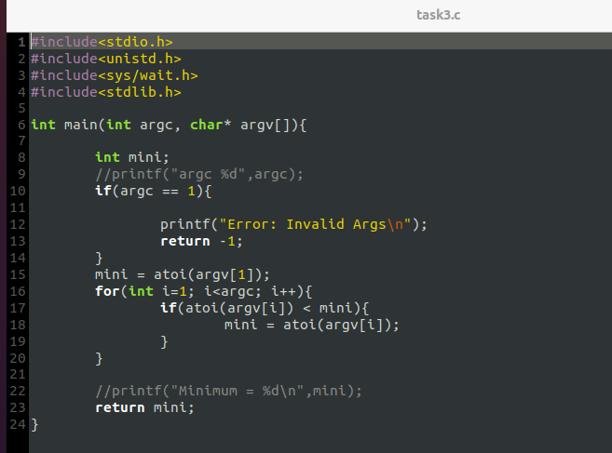

**Output:**

